CHAPTER III
1. What is yoga?
A) A physical exercise
B) A mental discipline
C) A spiritual practice
D) All of the above
Answer: D) All of the above
2. Where did yoga originate?
A) India
B) China
C) Japan
D) Europe
Answer: A) India
3. What is the purpose of yoga?
A) To alleviate health problems
B) To reduce stress
C) To make the spine supple
D) All of the above
Answer: D) All of the above
4. What are the characteristics of yoga?
A) Exercise of skeletal muscles
B) Intra-thoracic and intra-abdominal pressure
C) Little expenditure of energy and money
D) All of the above
Answer: D) All of the above
5. Who can practice yoga?
A) Only rich people
B) Only poor people
C) Men and women of all ages
D) Only athletes
Answer: C) Men and women of all ages
6. What is the nature of yogic practices?
A) Physical
B) Mental
C) Psycho-neurophysical
D) Spiritual
Answer: C) Psycho-neurophysical
7. What is Padmasana?
A) A sitting posture
B) A standing posture
C) A lying down posture
D) A walking posture
Answer: A) A sitting posture
8. What is the benefit of Padmasana?
A) It helps in curing diseases like asthma and hysteria
B) It improves flexibility
C) It reduces stress
D) All of the above
Answer: D) All of the above
9. What is Siddhasana?
A) A sitting posture
B) A standing posture
C) A lying down posture
D) A walking posture
Answer: A) A sitting posture
10. What is the benefit of Siddhasana?
A) It helps in awakening the power of Kundalini
B) It improves flexibility
C) It reduces stress
D) All of the above
Answer: A) It helps in awakening the power of Kundalini
11. What is Gyan Mudra?
A) A hand gesture
B) A sitting posture
C) A breathing technique
D) A meditation technique
Answer: A) A hand gesture
12. What is the benefit of Gyan Mudra?
A) It improves concentration
B) It reduces stress
C) It improves memory
D) All of the above
Answer: D) All of the above
13. What is Suryanamaskara?
A) A series of 12 postures
B) A breathing technique
C) A meditation technique
D) A relaxation technique
Answer: A) A series of 12 postures
14. What is the benefit of Suryanamaskara?
A) It improves flexibility
B) It reduces stress
C) It improves circulation
D) All of the above
Answer: D) All of the above
15. What is Shavasana?
A) A relaxation technique
B) A breathing technique
C) A meditation technique
D) A physical posture
Answer: A) A relaxation technique
16. What is the benefit of Shavasana?
A) It reduces stress and anxiety
B) It improves sleep
C) It improves concentration
D) All of the above
Answer: D) All of the above
17. What is Vajrasana?
A) A sitting posture
B) A standing posture
C) A lying down posture
D) A walking posture
Answer: A) A sitting posture
18. What is the benefit of Vajrasana?
A) It improves digestion
B) It reduces gas troubles
C) It improves flexibility
D) All of the above
Answer: D) All of the above
19. What is Dhanurasana?
A) A backbend posture
B) A forward bend posture
C) A sitting posture
D) A standing posture
Answer: A) A backbend posture
20. What is the benefit of Dhanurasana?
A) It improves flexibility
B) It strengthens back muscles
C) It improves digestion
D) All of the above
Answer: D) All of the above
21. What is Chakrasana?
A) A backbend posture
B) A forward bend posture
C) A sitting posture
D) A standing posture
Answer: A) A backbend posture
22. What is the benefit of Chakrasana?
A) It improves flexibility
B) It strengthens back muscles
C) It improves circulation
D) All of the above
Answer: D) All of the above
23. What is Sarvangasana?
A) A shoulder stand posture
B) A headstand posture
C) A sitting posture
D) A standing posture
Answer: A) A shoulder stand posture
24. What is the benefit of Sarvangasana?
A) It improves circulation
B) It improves thyroid function
C) It reduces stress
D) All of the above
Answer: D) All of the above
25. What is Halasana?
A) A plow pose posture
B) A shoulder stand posture
C) A headstand posture
D) A sitting posture
Answer: A) A plow pose posture
26. What is the benefit of Halasana?
A) It improves flexibility
B) It improves circulation
C) It reduces stress
D) All of the above
Answer: D) All of the above
27. What is the purpose of yoga?
A) To improve physical health
B) To improve mental health
C) To achieve spiritual growth
D) All of the above

Answer: D) All of the above
28. What is the role of yoga in stress management?
A) It reduces stress
B) It increases stress
C) It has no effect on stress
D) It depends on the individual
Answer: A) It reduces stress
29. How does yoga affect the body?
A) It improves flexibility
B) It strengthens muscles
C) It improves circulation
D) All of the above
Answer: D) All of the above
30. What is the importance of breathing in yoga?
A) It improves oxygenation
B) It reduces stress
C) It improves circulation
D) All of the above
Answer: D) All of the above
31. What is the role of yoga in mental health?
A) It reduces anxiety
B) It reduces depression
C) It improves mood
D) All of the above
Answer: D) All of the above
32. How can yoga be incorporated into daily life?
A) Through regular practice
B) Through meditation
C) Through breathing techniques
D) All of the above
Answer: D) All of the above
33. What is the benefit of regular yoga practice?
A) It improves physical health
B) It improves mental health
C) It improves spiritual growth
D) All of the above
Answer: D) All of the above
34. Can yoga be practiced by people of all ages?
A) Yes
B) No
C) Only by young people
D) Only by old people
Answer: A) Yes
35. Is yoga a form of exercise?
A) Yes
B) No
C) Only physical exercise
D) Only mental exercise
Answer: A) Yes
36. What is the role of yoga in improving flexibility?
A) It increases range of motion
B) It reduces stiffness
C) It improves balance
D) All of the above
Answer: D) All of the above
37. Can yoga help with weight management?
A) Yes
B) No
C) Only through physical postures
D) Only through meditation
Answer: A) Yes
38. What is the benefit of yoga for cardiovascular health?
A) It reduces blood pressure
B) It improves circulation
C) It reduces risk of heart disease
D) All of the above
Answer: D) All of the above
39. Can yoga be practiced by people with injuries?
A) Yes
B) No
C) Only with medical supervision
D) Only after full recovery
Answer: C) Only with medical supervision
40. What is the importance of proper alignment in yoga?
A) It prevents injury
B) It improves flexibility
C) It improves balance
D) All of the above
Answer: D) All of the above
41. What is the role of yoga in reducing stress and anxiety?
A) It reduces cortisol levels
B) It improves mood
C) It improves sleep
D) All of the above
42. Can yoga be practiced in groups?
A) Yes
B) No
C) Only with a qualified instructor
D) Only with experienced practitioners
43. What is the benefit of yoga for bone health?
A) It improves bone density
B) It reduces risk of osteoporosis
C) It improves flexibility
D) All of the above
Answer: D) All of the above
44. Can yoga help with management of chronic diseases?
A) Yes
B) No
C) Only with medical supervision
D) Only after full recovery
Answer: A) Yes
45. What is the role of yoga in improving immune function?
A) It reduces stress
B) It improves circulation
C) It boosts immune system
D) All of the above
Answer: D) All of the above
46. Can yoga be practiced by people with different fitness levels?
A) Yes
B) No
C) Only by athletes
D) Only by beginners
Answer: A) Yes
47. What is the importance of listening to the body in yoga?
A) It prevents injury
B) It improves flexibility
C) It improves balance
D) All of the above
Answer: A) It prevents injury
48. Can yoga help with improving sleep quality?
A) Yes
B) No
C) Only through meditation
D) Only through physical postures
Answer: A) Yes
49. What is the role of yoga in reducing symptoms of menopause?
A) It reduces hot flashes
B) It improves mood
C) It improves sleep
D) All of the above
Answer: D) All of the above
50. Can yoga be used as a complementary therapy?
A) Yes
B) No
C) Only with medical supervision
D) Only after full recovery
Answer: A) Yes
51. What is the benefit of yoga for cognitive function?
A) It improves memory
B) It improves concentration
C) It improves problem-solving skills
D) All of the above
Answer: D) All of the above
52. Can yoga help with reducing symptoms of anxiety disorders?
A) Yes
B) No
C) Only through meditation
D) Only through physical postures
Answer: A) Yes
53. What is the role of yoga in improving overall well-being?
A) It reduces stress
B) It improves mood
C) It improves sleep
D) All of the above
Answer: D) All of the above
54. Can yoga be practiced in nature?
A) Yes
B) No
C) Only in a studio
D) Only at home

Answer: A) Yes
55. What is the benefit of yoga for cardiovascular health?
A) It reduces blood pressure
B) It improves circulation
C) It reduces risk of heart disease
D) All of the above
Answer: D) All of the above
56. Can yoga help with weight management?
A) Yes
B) No
C) Only through physical postures
D) Only through meditation
Answer: A) Yes
57. What is the importance of proper breathing in yoga?
A) It improves oxygenation
B) It reduces stress
C) It improves circulation
D) All of the above
Answer: D) All of the above
58. Can yoga be used as a tool for stress management?
A) Yes
B) No
C) Only through meditation
D) Only through physical postures
Answer: A) Yes
59. What is the role of yoga in improving flexibility and range of motion?
A) It increases flexibility
B) It reduces stiffness
C) It improves balance
D) All of the above
Answer: D) All of the above
60. Can yoga be practiced by people of all ages and abilities?
A) Yes
B) No
C) Only by young people
D) Only by athletes
Answer: A) Yes
61. What is the role of yoga in improving mental clarity and focus?
A) It reduces stress
B) It improves concentration
C) It improves memory
D) All of the above
Answer: D) All of the above
62. Can yoga help with reducing symptoms of depression?
A) Yes
B) No
C) Only through meditation
D) Only through physical postures
Answer: A) Yes
63. What is the importance of relaxation in yoga?
A) It reduces stress
B) It improves flexibility
C) It improves balance
D) All of the above
Answer: A) It reduces stress
64. Can yoga be used as a tool for improving self-awareness?
A) Yes
B) No
C) Only through meditation
D) Only through physical postures
Answer: A) Yes
65. What is the role of yoga in improving overall health and well-being?
A) It reduces stress
B) It improves physical health
C) It improves mental health
D) All of the above
Answer: D) All of the above
66. Can yoga be practiced in a group setting?
A) Yes
B) No
C) Only with a qualified instructor
D) Only with experienced practitioners
Answer: A) Yes
67. What is the benefit of yoga for improving balance and coordination?
A) It improves balance
B) It improves coordination
C) It reduces risk of falls
D) All of the above
Answer: D) All of the above
68. Can yoga help with reducing symptoms of chronic pain?
A) Yes
B) No
C) Only through physical postures
D) Only through meditation
Answer: A) Yes
69. What is the role of yoga in improving immune function?
A) It reduces stress
B) It improves circulation
C) It boosts immune system
D) All of the above
Answer: D) All of the above
70. Can yoga be used as a tool for improving relationships?
A) Yes
B) No
C) Only through meditation
D) Only through physical postures
Answer: A) Yes
71. What is the benefit of yoga for improving overall quality of life
A) It reduces stress
B) It improves physical health
C) It improves mental health
D) All of the above
Answer: D) All of the above
72. Can yoga be practiced by people with different cultural backgrounds?
A) Yes
B) No
C) Only by people from India
D) Only by people from Western countries
Answer: A) Yes
73. What is the role of yoga in improving cognitive function?
A) It improves memory
B) It improves concentration
C) It improves problem-solving skills
D) All of the above
Answer: D) All of the above
74. Can yoga help with reducing symptoms of anxiety and depression?
A) Yes
B) No
C) Only through meditation
D) Only through physical postures
Answer: A) Yes
75. What is the overall benefit of practicing yoga?
A) It improves physical health
B) It improves mental health
C) It improves overall well-being
D) All of the above
Answer: D) All of the above
76. Dhanurasana is also known as
A)Dogpose
B)Bowpose
C)catpose
d)horsepose
answer:B)bowpose
77.sarvangasana is a _______position.
a) handstand
b)hipstand
c)shoulderstand
d)legstand
answer:shoulderstand
78.which yogasana is described as completely relaxed position___
A)halasana
B)shavasana
c)chakrasana
d)sarvangasana
answer: shavasana
IDENTIFY THE POSTURES/ ASANAS
79. 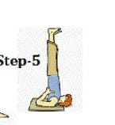___________________________ Answer: SARVANGASANA
80. 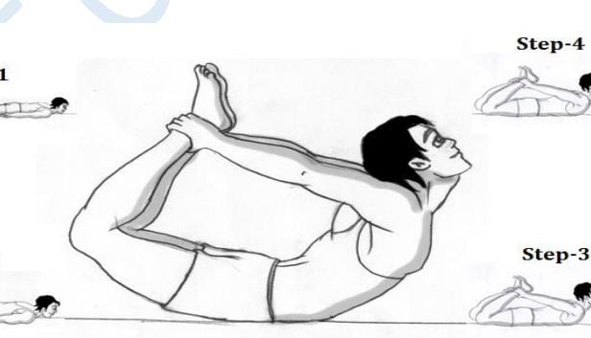__________________ ANSWER: DHANURASANA
81. 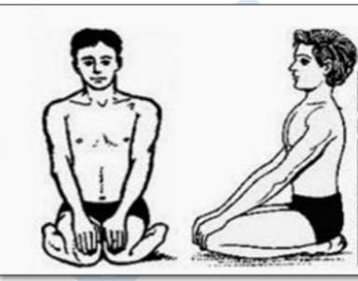__________________ANSWER: VAJRASANA
82. 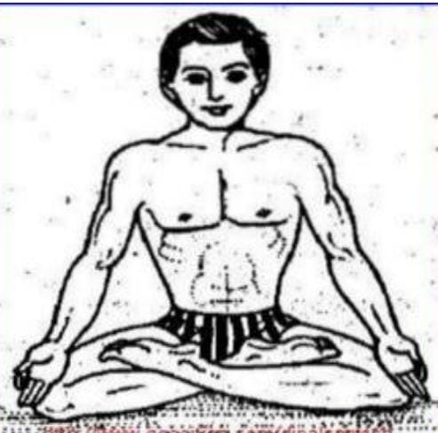___________________ANSWER: SIDDHASANA/PADMASANA
83. 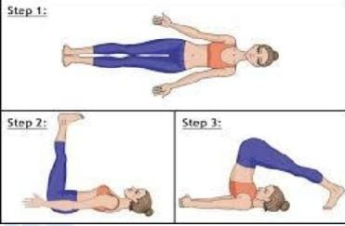_________________ANSWER: HALASANA
84. 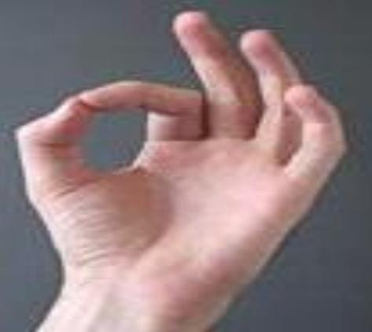_________________ANSWER: GYAN MUDRA
85. 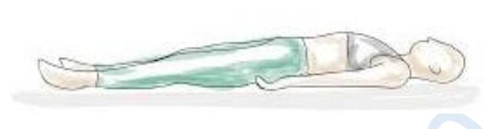_________________ANSWER: SHAVASANA

